Real-Life Smartphone Physics:
Examine your own hearing threshold
with a smartphone

___________________________________
Name
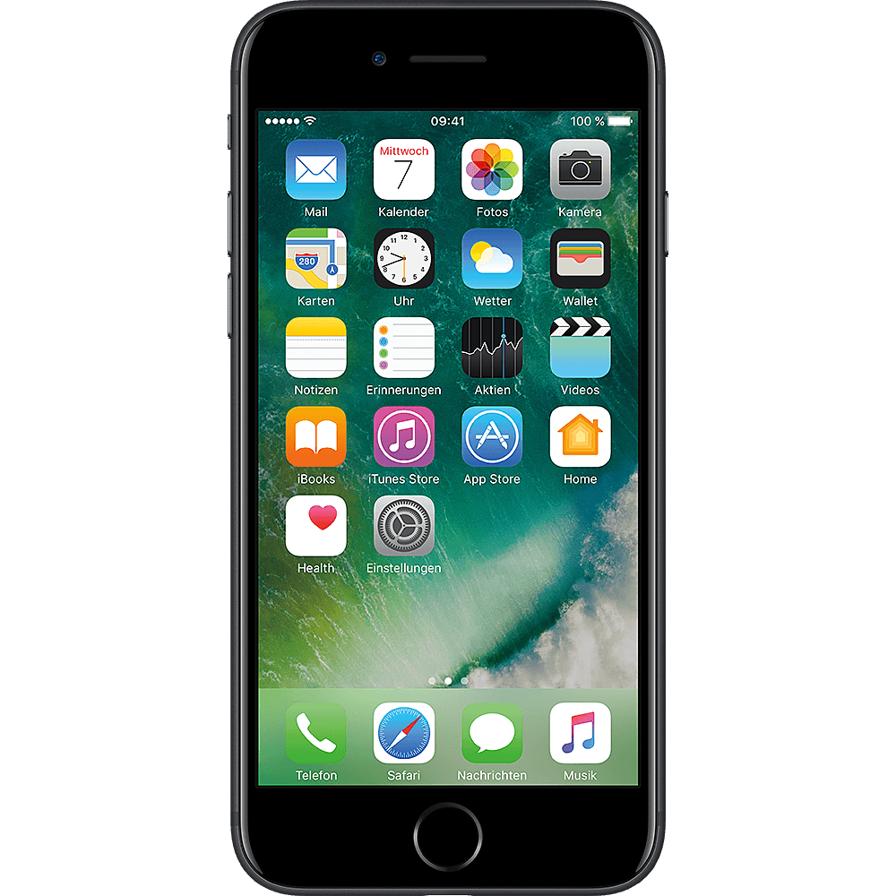
Audiometric Test
Audiometric test with a smartphone

- Which of the following factors could distort a hearing test? Check.

Root cause | can  distort | can not  distort
Body size
Traffic noise
Conversations in the room
Gender
Respiratory rate
Loose headphone contact

In the following hearing test, be sure to do it in a quiet environment and avoid interference. If possible, use the headphones that came with your smartphone.

- Conduct audiometric test with the iOS app (alternative for Android smartphones: see last page)

    - Open the app Hearing Test & Ear Age Test or download the app.

    - Start Hearing Test and follow the instructions on the screen.

    - At the end you get a graph. Press Share and then Save Image.

- Open Fotos and look at the results of your hearing test. The graph shows how well you hear different tones. The tones are getting higher and higher from left to right.

- What may have disturbed / influenced the measurement?
        - ____________________________________________________________________
        - ____________________________________________________________________
        - ____________________________________________________________________
        - ____________________________________________________________________

- Read the dB-HL for the seven frequencies and both ears from the audiogram, enter the values in the following table and calculate the mean of both ears!
 | 125 Hz | 250 Hz | 500 Hz | 1000 Hz | 2000 Hz | 4000 Hz | 8000 Hz
Left ear
Right ear
Mean
Enter the means in the following online table: http://did.physik.lmu.de/qr/q.php?c=zsb
- Compare
      - Compare your result with the results of your classmates.

      - Who can hear best …?
… conversations (2.0 kHz): ________________________________________________
… at a frequency of 8.0 kHz: ___________________________________________
… at a frequency of 0.125 kHz: _________________________________________

      - Who can hear best overall?

Name: __________________________________________

      - How did you know who heard best?
________________________________________________________________
________________________________________________________________
________________________________________________________________

- The process of hearing – put the appropriate words in the blank spaces!

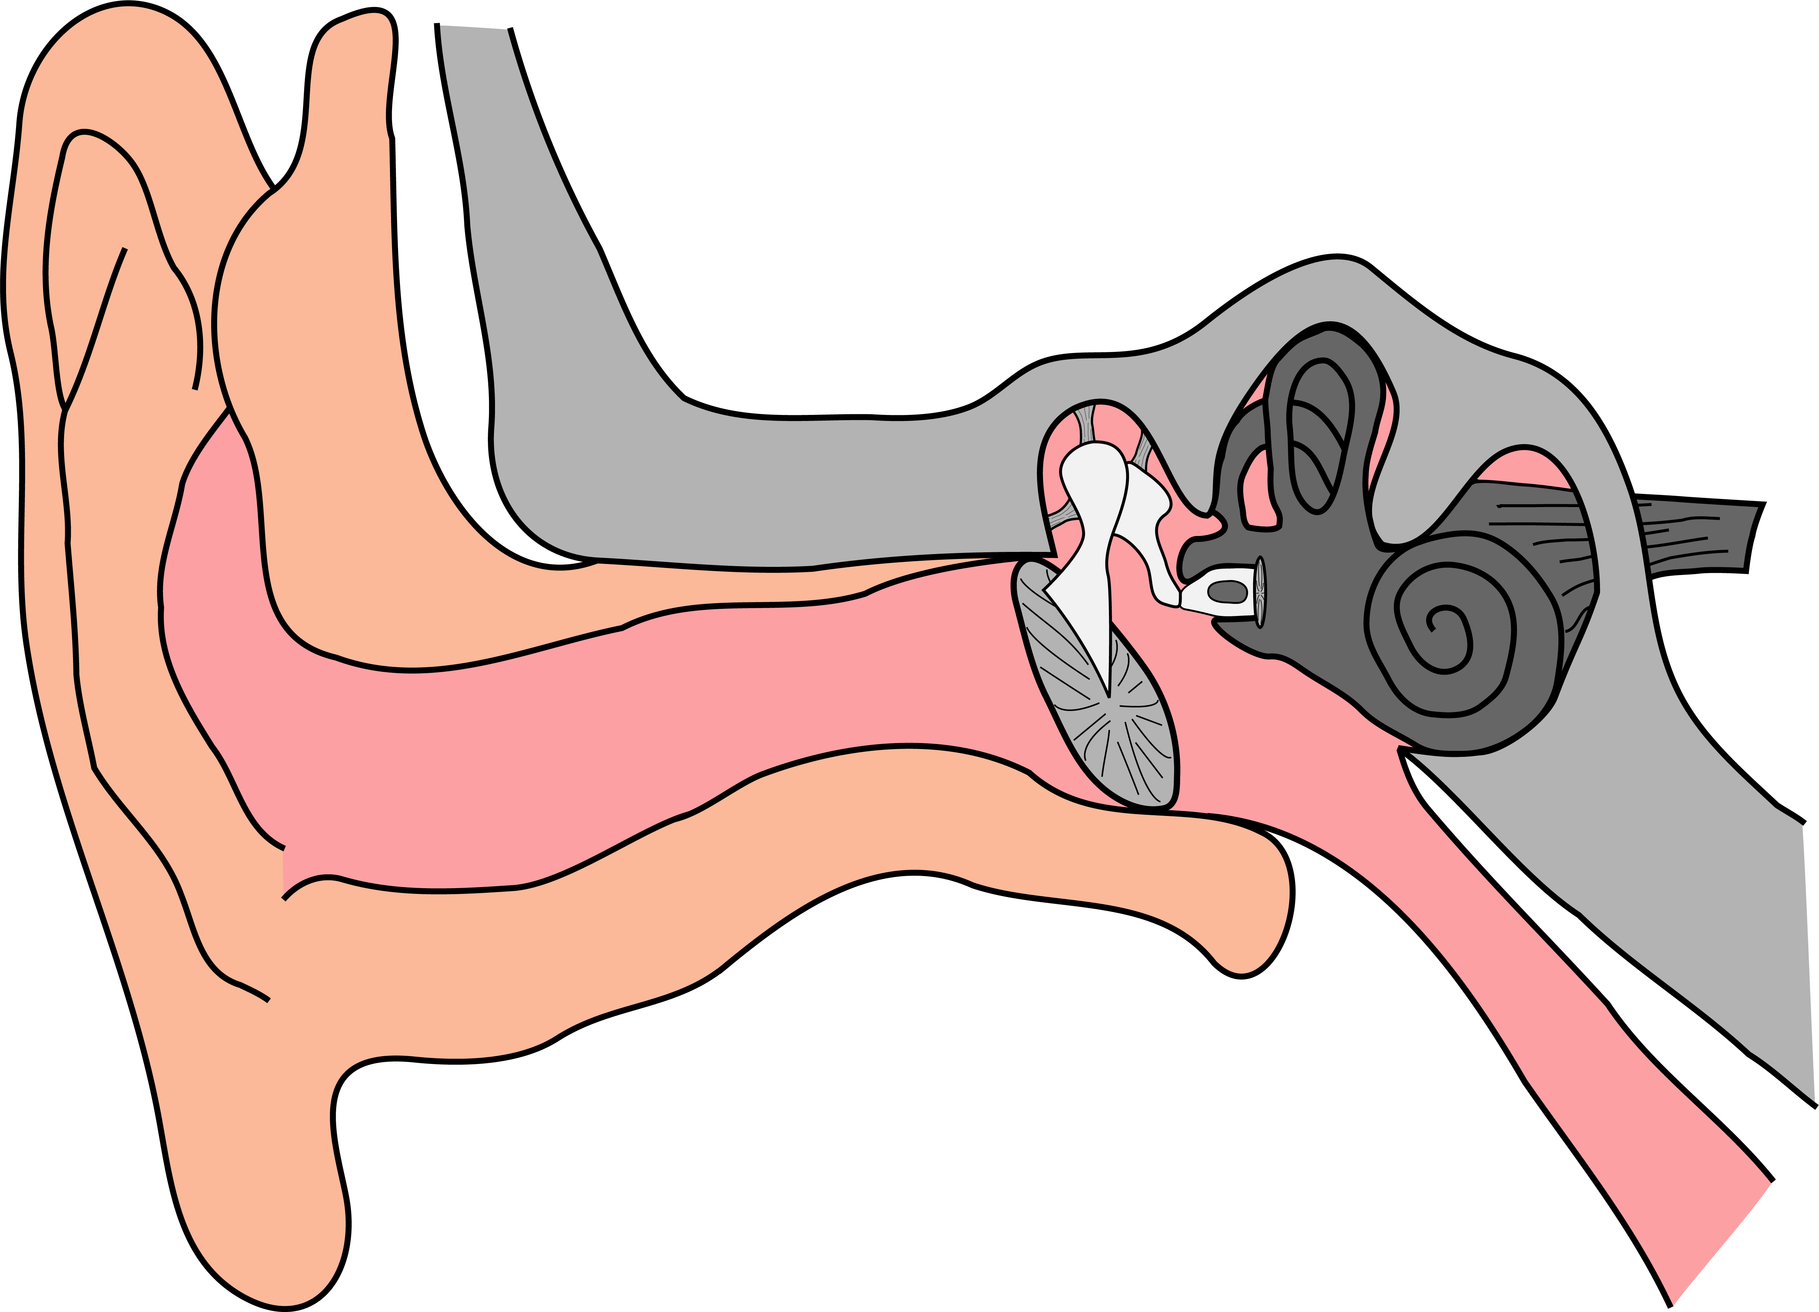

The _____________________________ hit the pinna. There they are passed through the ear canal to the middle ear. The _____________________________ sits in the middle ear and begins to vibrate. There are fine _____________________________ in the cochlea. The _____________________________ eardrum stimulates them to vibrate via several intermediate stations.
There are _____________________________ under the fine sensory hairs, which register the _____________________________ and pass them on to the _____________________________. Different sensory hairs are stimulated depending on the _____________________________. We hear tones around a frequency of 3.5 kHz the _____________________________. We perceive tones with lower or higher frequency the _____________________________.

sensory hairs | brain | loudest | quietest | vibrating
nerves | sound waves | ear drum | movements | tone
For Android smartphones
An alternative app for Android smartphones is e.g. Hörtest by e-audiologia.pl.

You can download it for free: https://play.google.com/store/apps/details?id=mobile.eaudiologia

